**严禁抄袭，查重出现相同／相似内容超过50字，计0分**

**题目基本按照难度递增的顺序，其所对应的分数比例也不同.**

1. Voltage-clamp recordings of giant axons reveal presence of two types of voltage-dependent membrane currents, i.e. voltage-dependent Na+ and K+ currents, mixed together. On basis of their pharmacological and electrophysiological properties, design two independent experiments that allow separation of these two currents.

**Experiment I**: Use TTX and 4-AP to block voltage-dependent Na+ channels and voltage-dependent K+ channels, respectively. Then use voltage clamp to clamp membrane potential to +30mV and record the currents induced by Na+ channels or K+ channels.

**Experiment II**: From the electrophysiological properties, we know that K+ channels contain a delay between stimulus and permeability change, whereas Na+ channels would be inactive rapidly but without a delay. These properties indicate that 10ms after stimulus the current is mainly caused by Na+ channel and after this, the current is caused by K+ channels.

1. What kinds of sensory information do you think the cerebellum might need in order to compare intended movements with actual movements? How does the cerebellum get its sensory input? Diagram the circuits for learning to reduce movement error.

**Sensory information**: vestibular sense, auditory sense, visual sense and proprioception.

**Way to get its sensory input**: In cerebellum, only vestibulocerebellum and spinocerebellum accept the peripheral sensory inputs. In vestibulocerebellum, axons from vestibular nuclei project to it so that it can get vestibular sensory input. Spinocerebellum, the part mainly to reduce movement error, is projected by axons from spinal cord, visual organs and auditory organs in order to gets information of proprioception, visual sense and auditory sense inputs.

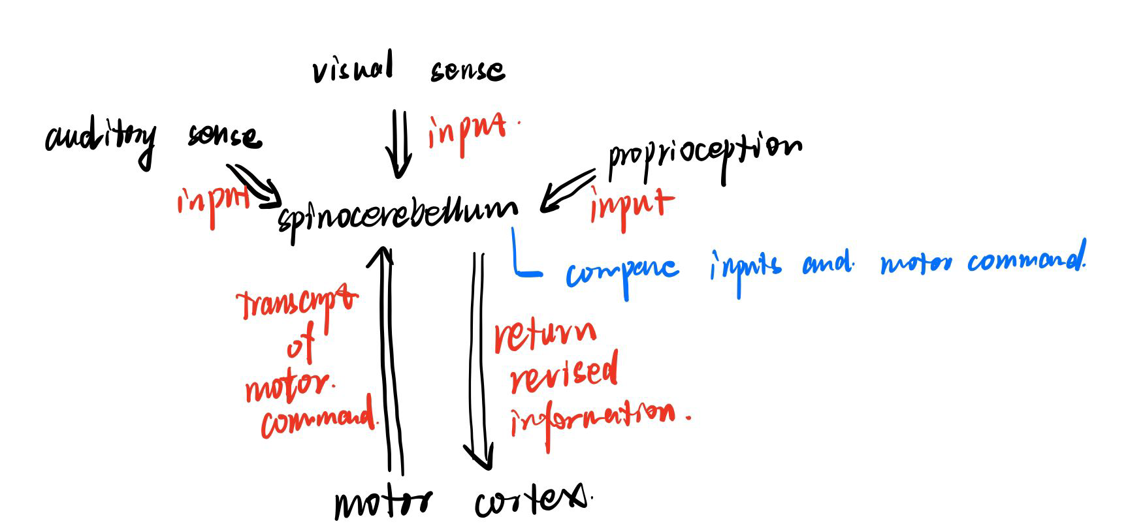

1. Projection neurons in mammalian brains have complicated morphology with distinct set of projection targets. Thus, imaging and tracing single neuron morphology is time consuming and labor intensive. How are you going to speed up the imaging and reconstruction process? In your mind, how detailed neuron morphology is going to help study in cognitive functions?

**Process**: In electrophysical experiments, the microelectrodes is usually be used to detect the change of membrane potential. With these microelectrodes, we can also inject fluorescence material to stain a single neuron and observe its morphology under fluorescence microscope.

Further, to determine the connection between neurons, we can modify virus capsid protein with GFP. Street virus is capable to move in neuron via reverse axle slurry transport and move through synapses. With genetic modify, we can make street virus can just pass through synapses only once. After inject street virus in a certain neuron, all presynaptic neurons can also be labeled by street virus.

To my perspective, investigation on the level of circuit is a very important part of cognitive neuroscience research. Study of detailed morphology reveal the space location of neurons which facilitated the relationship among certain neuron with neurons in the same of different area of brain, lay the foundation to build the pattern of neuron connections in brain.

1. Compare and contrast the sensory signal transduction cascades between mechanosensory neurons and retina rods and cones.

|  |  |  |
| --- | --- | --- |
| Type | **Rods and Cones** | **Mechanosensory neurons** |
| Stimuli | Light | Mechanically stimuli |
| Receptor | GPCR | Mechanically gated cation channels |
| Downstream signal | second messenger | depolarization |
| Change of membrane potential | hyperpolarization | form action potential |
| Result | release transmitters | release transmitters |

1. The Synaptic Plasticity and Memory hypothesis are one of most extensively studied hypothesis, which is formulated as below:

“Activity-dependent synaptic plasticity is induced at appropriate synapses during memory formation, and is both necessary and sufficient for the encoding and trace storage of the type of memory mediated by the brain area in which that plasticity is observed.”

On basis of your understanding of scientific principles, identify distinct criteria of assessment and corresponding tests of the SPM hypothesis. And design one experiment to test one of criteria you listed.

**Criteria**:

First, *detectability*, mains that there must be detectable change in synapse after learning.

Second, *anterograde alteration*, mains that if treatment (physical, genetic etc.) which can alter synaptic plastic is given to the synapses before learning, there should be predictable change to rate of learning.

Third, *retrograde alteration*, mains that treatment (as above) given to experimental subject after learning would alter the behavior of subject.

Fourth, *mimicry*, mains that artificial alternation to synaptic plastic pattern would induce the “false memory” without training or learning. [1]

**Experiment to test detectability**: Use genetic technique to link AMPA-R with GFP, choice hippocampus specific promoter and control it via tetracycline-controlled system. Determine the magnitude of fluorescence on the CA1 pyramid neuron synapse and the result indicate that the strength of fluorescence is significant increase after stimulate to experimental animal.

1. What is meaning of “silent synapse”? Design two independent experiments to demonstrate the presence of “silent synapse” in the hippocampus.

**Silent synapse**: It refers to synapse which only contain NMDA receptor without AMDA receptor on postsynaptic membrane and in this case, the postsynaptic neuron cannot respond to the presynaptic stimuli, but they can convert to normal synapse in certain conditions.

**Experiment I**: We can give stimuli to the presynaptic axons in hippocampus and determine the postsynaptic membrane potential. In this experiment, some postsynaptic neurons have no potential respond to presynaptic stimuli. Thus, we can speculate that these synapses are silent synapses.

**Experiment II**: We can use immunocytochemical technique to determine the presence of silent synapses in hippocampus. Label antibodies anti NMDA-R and AMPA-R with different fluorescence labels, respectively. Incubate the slice of hippocampus with the antibodies and then demonstrate the slice with fluorescence microscope. Synapses, only with NMDA-R present, are silent synapses.

1. Anatomical and neurophysiology evidence support that the cortico-basal ganglia-thalamo-cortical circuits are organized in parallel loops conveying different information. However, there is huge convergence from striatum (~100,000,000 neurons) to globus pallidus (~700,000), with on average more than 100 MSNs innervating each cell in GP. Given the huge convergence, how could information be segregated in the circuits? In terms of action selection, how could this be achieved in the basal ganglia system? Provide one hypothetical model to link the anatomical organization with action selection. How are you going to verify this experimentally?

It is assumed that neurons from striatum target different positions of dendrites or cell bodies in the lateral part of globus pallidus, so as to transform the information carried by neurons in different anatomical positions of striatum into temporal information issued by action potentials, thus ensuring effective encoding and separation of information.

**Validation:**

(1) Anatomy: Anterograde non-trans synaptic virus was injected into the striatum GABAergic neurons of mice. After the expression of the virus, fibers from the striatum were directly observed in the cell bodies and dendrites of Gpe neurons under a high-resolution confocal microscope.

(2) Electrophysiology: Photogenetic stimulation of striatum GABAergic neurons could detect EPSP at different locations and cell bodies of Gpe neuron dendrites, and record the time and amplitude of spike.

(3) Optogenetics: Gpe Neurons are activated or inhibited by high-frequency or low-frequency light stimulation. Residence time in wheel experiment and average speed in pole climbing experiment are observed.

Light stimulation activated or inhibited the dendrites or cell bodies from Gpe GABAergic, and observed the residence time of mice in the wheel experiment and the average speed of mice in the bar climbing experiment.

1. Neurons in face patches middle lateral (ML)/middle fundus (MF) and anterior medial (AM) respond to different faces. Each person on average knows more than one thousand others during daily life. And this number can grow to many thousands if including famous people (politicians, sports stars, movie stars, famous scientists et al). How do face selective neurons encode different faces? How are you going to study this question? Please list detailed hypothesis, experimental design and expected results.

**Hypothesis**:

Neurons in face recognition area undertake the function that recognize different features of face like diameter of eyes, skin color, type of hair etc. When the feature of model changes, the relative neurons’ firing pattern will also change.

**Experimental design**:

Use single cell recording method, determine the neurons in face patches in alive experiment animal.

Prepare pictures and models of faces. Each of them just different in a single feature, like the length of hair or color of skin.

Put pictures or models behind experimental animal and record firing patterns of each neurons.

Analysis the firing patterns of the neurons among two relative pictures or models, then determine the neurons whose firing pattern changed.

**Expected result**:

The result indicates that there are really some neurons in face patches which are respond to change of certain feature of pictures or model and change there firing pattern. This result proves that the way brain coding the information of faces is via the recognition and storage of each features of faces and the whole information of faces is the permutation and combination of these features.

[1] Tomonori Takeuchi, Adrian J. Duszkiewicz, and Richard G. M. Morris.The synaptic plasticity and memory hypothesis: encoding, storage and persistence[J].Philos Trans R Soc Lond B Biol Sci,2014,:.